**Produce a Draft Logical ERD (aka Table Diagram) representing your Data Model**

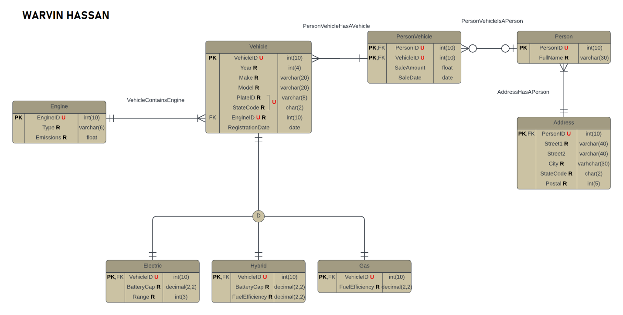

*Using LucidChart*

**Explain how you turned your previous (conceptual) ERD into a final logical ERD (aka Table Diagram)**

I simply used this drawing I made from part 2. I had already done everything so all I really needed to do was implement it and this diagram was already in 3NF.

Also since, there was a bridge table for “Vehicle” and “Person” called “PersonVehicle” this has a composite primary key. There are also 3 disjoint subtypes for “Vehicle” called “Electric”, “Hybrid”, and “Gas”. The relationships were also already stated from part 2. The same goes for PKs and FKs.

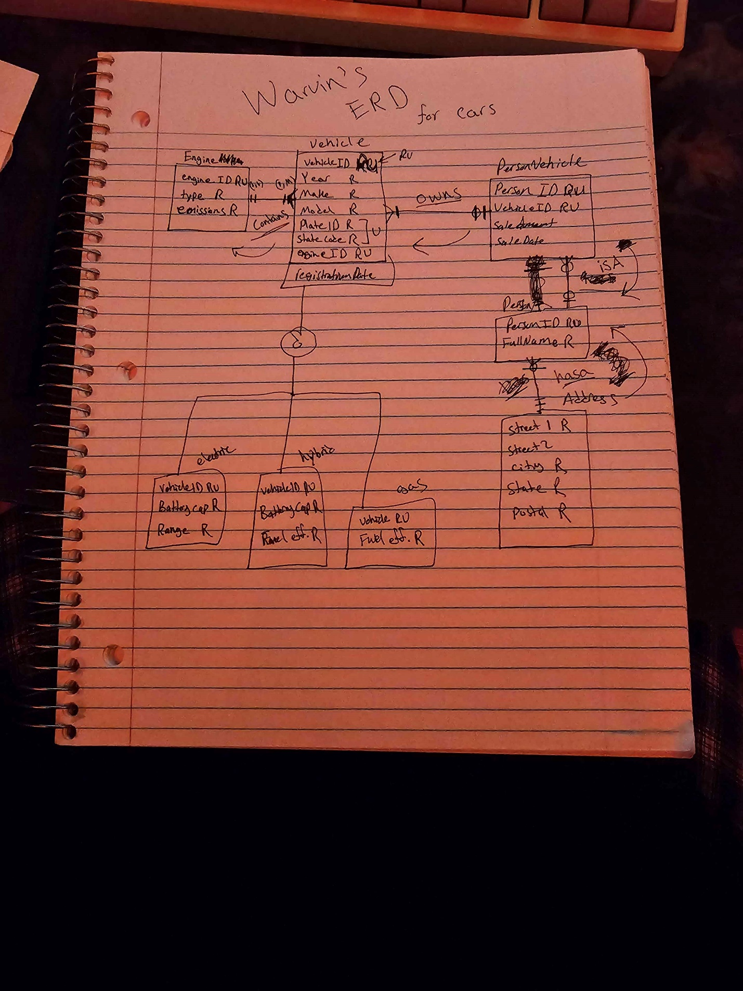

**Create Dependency Diagrams for each Entity of the Database**

**Person Table**:

PersonID → FullName

PersonID → Address (since PersonID is linked to the Address table)

**Vehicle Table**:

VehicleID → Year, Make, Model, PlateID, StateCode, EngineID, RegistrationDate

**Engine Table**:

EngineID → Type, Emissions

**PersonVehicle Table** (composite key):

PersonID, VehicleID → SaleAmount, SaleDate

**Address Table**:

PersonID → Street1, Street2, City, StateCode, Postal

**Subtypes (Electric, Hybrid, Gas)**:

VehicleID → BatteryCap, Range, FuelEfficiency

Since all non-key attributes are functionally dependent on the primary key of their respective tables, and there are no transitive dependencies, this confirms the schema is in 3NF.

Also here is the mock data

